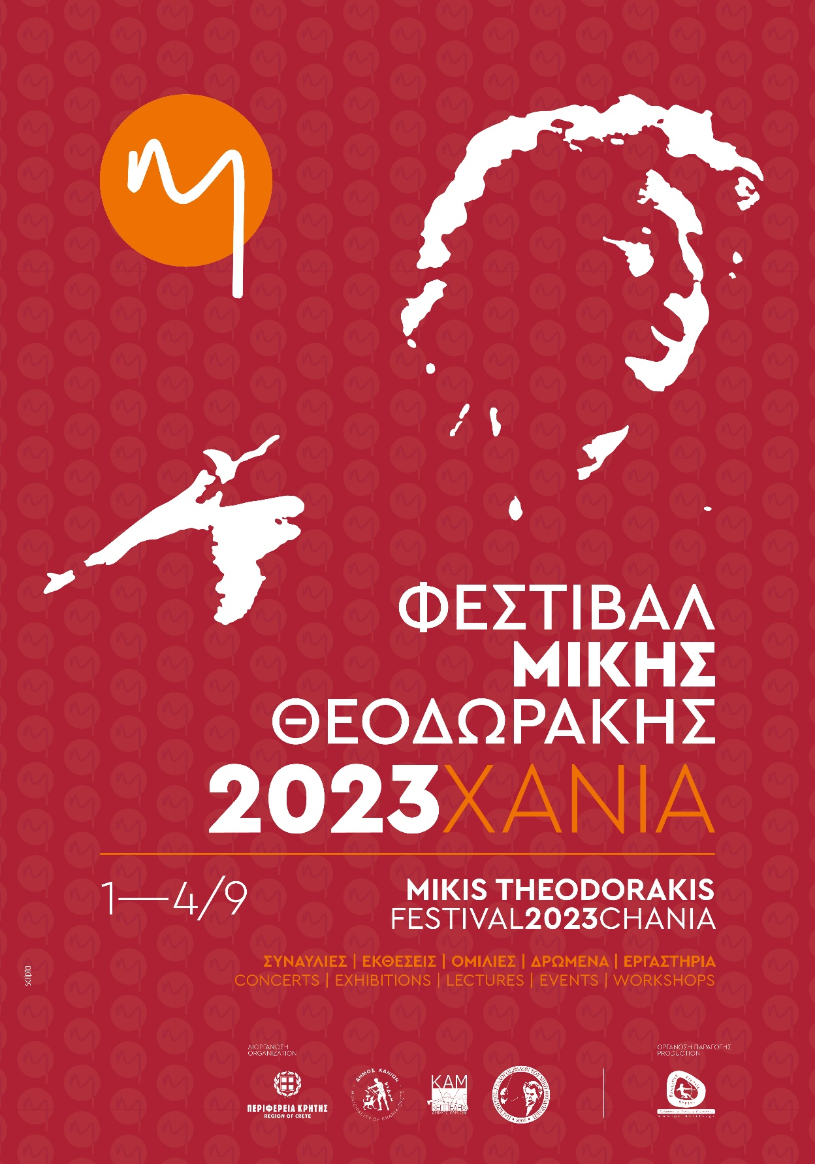

PRESS RELEASE
"Mikis Theodorakis Festival 2023"
Chania 1-4 September 2023

Two years after the death of the Top Composer, his place, honoring his Memory, continues with a rich program the "Mikis Theodorakis Festival", which has been held since 2015 in Chania. An international event, designed to approach all aspects of Mickey's personality. The Folk, the Classical, the Lyrical, the Thinker, the Creator who dared!
The "Mikis Theodorakis Festival 2023" comes at the beginning of September in Chania and includes a rich program of central and parallel events, with the presence of great artists and important personalities.
Organisation: Region of Crete
Municipality of Chania
KEPPEDICH – KAM
Pancretian Association of Friends of Miki Theodorakis
Production Organization: Cultural Society of Crete

ENTRY IS FREE TO ALL EVENTS

MIKIS THEODORAKIS FESTIVAL 2023
FRIDAY 1 SEPTEMBER 2023 – MONDAY 4 SEPTEMBER 2023
• FRIDAY SEPTEMBER 1, 2023
MARIA FARANDOURI SINGS MIKI THEODORAKIS, TIME 9.00 P.M. THEATER ANATOLIKIS TAFROU, CHANIA
• SATURDAY, SEPTEMBER 2, 2023
• GALATAS CHANION, TIME 11.00 A.M.
- ANNUAL MEMORIAL OF MIKIS THEODORAKIS, GALATA CEMETERY, CHANIA
- NAMING OF CHANION-KOLYMBARIOU OLD NATIONAL ROAD to: "MIKIS THEODORAKIS AVENUE"
- THE MIXED CHOIR OF THE REGIONAL UNIT OF HERACLEIO IN SONGS OF MIKIS , HOUSE OF THEODORAKIS FAMILY, GALATAS, CHANIA
• MIKIS THEODORAKIS THEATER, VENETIAN PORT OF CHANIA, TIME 7.30 P.M.
- SPEECH ON THE SUBJECT: "UNIVERSAL HARMONY AND SOCIAL DISHARMONY", YIANNIS KOUGIOUMTZAKIS, EMERITUS PROFESSOR OF PSYCHOLOGY UNIVERSITY OF CRETE
- "REHEARSAL WITH MIKIS ON POLIVO STREET", KONSTANTINOS MANOLKIDIS, GUITAR SOLOIST
• SUNDAY, SEPTEMBER 3, 2023
- "THE CLASSIC MIKIS THEODORAKIS FOR SOLO PIANO", APOSTOLOS PALIOS, SOLOIST PIANO, DOCTOR OF MUSICOLOGY
MEDITERRANEAN ARCHITECTURE CENTER, VENETIAN PORT OF CHANIA, TIME 12.00 NOON
- "WE ARE 1013...", VENETIAN PORT OF CHANIA, TIME 7.00 PM.
• MONDAY SEPTEMBER 4, 2023
- SPEECH ON: "THE ECCLESIASTICAL COMPOSITIONS OF MIKIS THEODORAKIS", PANAGIOTIS ANDRIOPOULOS, MUSICOLOGIST, TEACHER
MEDITERRANEAN ARCHITECTURE CENTER, VENETIAN PORT OF CHANIA, TIME 7.30 P.M.
- CHRISTOFOROS STABOGLIS INTERPRETS TOP CREATIONS OF MIKIS. DIMITRIS YAKAS AT THE PIANO
MIKIS THEODORAKIS THEATRE, VENETIAN PORT OF CHANIA, TIME 8.30 P.M.
PARALLEL ACTIONS
• MONDAY 28 AUGUST 2023 – SUNDAY 10 SEPTEMBER 2023, MEDITERRANEAN ARCHITECTURE CENTER, 10 A.M. – 2.00 P.M. & 6.00 P.M. – 10.00 P.M. EXHIBITION "MIKIS IN THE WORLD" MIKIS POSTERS FROM AROUND THE WORLD & RARE EDITION MIKIS BOOKS BY AND ABOUT MIKIS EDITED BY: LEFTERIS LAMBRAKIS
• WEDNESDAY 30 AUGUST 2023 – THURSDAY 31 AUGUST 2023, MUNICIPAL CINEMA "KIPOS", TIME 9.00 PM. THE CHANIA FILM FESTIVAL PRESENTS THE MOVIE "SERPIKO"
• EXHIBITION: "MIKIS THEODORAKIS 1925-2021"
AT THE FAMILY HOME OF YIANNIS AND MIKIS THEODORAKIS IN GALATA, NOW THERE IS THE EXHIBTION "MIKIS THEODORAKI 1925 - 2021" ARCHIVE, WITH DOCUMENTS FROM MIKIS THEODORAKIS ARCHIVE & THE GREAT MUSIC LIBRARY OF GREECE "LILIAN VOUDOURI" .
THE EXHIBITION IS HELD IN CO-ORGANIZATION WITH THE "LILIAN VOUDOURI" MUSIC LIBRARY AND THE "FRIENDS OF MUSIC" ASSOCIATION.
PRE-FESTIVAL EVENT
• A CONCERT FOR MIKIS THEODORAKIS WITH KOSTAS THOMAIDIS AND IOANNA FORTI WAS HELD WITH THE PARTICIPATION OF THOUSANDS OF SPECTATORS AT KOLIMBARI, ON MONDAY, AUGUST 7, 2023.
THE CONCERT WAS HELD IN COLLABORATION WITH THE MUNICIPALITY OF PLATANIAS.

